Encryption Project
TARAS SVYNARCHUK
Contents
Aims and objectives 2
Analysis 3
Design 4
Developmental Testing. 5
Testing 6
Evaluation 1

Aims and objectives
Introduce your assignment here and detail your aims and objectives. The overall aim should be a paragraph, that explains why you have created the software, the objectives will be specific concepts or attributes you wish to include.

The objectives should be a numbered list so you can refer to them in your testing.

I’m aiming to build a simple tkinter application that will allow the user to select from a selection of ciphers, each of which will be present on their own page and the user can easily switch to and from. It should be easily understood and output the precise output after being processed in the backend. My app should try to solve the issue of not having several ciphers all in one place being easily accessible, which will be done by having several ways of switching between ciphers as quickly as possible.

- Make ciphers:
  - Caesar
  - Vernam
  - Enigma
  - RSA
- Create a dynamic app with a home page and a page for each cipher
- Create a frequency analysis tab displaying a bar chart for an input
- Add a return/back button for better user interface
- Add a quick copy output button for faster and more efficient usage
- Implement a switch button between encrypt and decrypt functions
- Create a Caesar cipher cracking function based on letter frequencies of the encrypted text

Analysis
The aim of analysis is to find any new ideas already programmed so you can ‘copy’ their ideas and advance them. You can find the code for the cyphers and different layouts for different systems. You should analyse anything you find identifying if you will or wont include them or if there are any features you will or wont be including.
This section should have lots of screen shots that are annotated to explain your thinking.

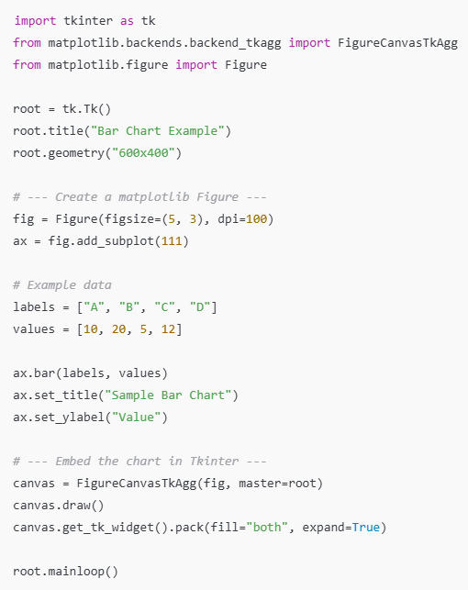
This snippet of code from chat gpt shows a very minimap way of implementing a matplotlib bar chart in tkinter.
Lines 10 and 11 show how to create a figure which is essentially the bar itself
Line 17 actually places the bar on a graph
Lines 22 through 24 place it in tkinter with basic some formatting and so it is displayed
Here I amended it to fit in my class structure.

Design
Outline your interface designs here, you should include enough detail so anyone else in the room could create your design and it would look the same. If you want to include a specific image or colour, reference this, including where to get the image from.
Describe the inputs, outputs and processes to be included.
Input | Processing | Output
Radio button choice | Select the chosen cypher | Identify the chosen cypher
Radio button choice for encryption/decryption | Select choice of operation | Identify the encryption/decryption choice
Plain text | Perform the correct operation – encrypting or decrypting | Cipher text
Cipher text | Perform the correct inverse operation – encrypting or decrypting | Plain text
Enciphered text | Count letter frequencies and create a bar chart to hold this data | The matplotlib bar chart in a mini window
Caesar encrypted text | Count letter frequencies and match the three most occurring ones to the letter ‘e’ | The three most likely decrypted solutions
Generate a random key - Vernam | Count the length of the plain text and generate a random key the same length as it using the random.randint method and converting them into ascii characters | The randomly generated key

Design your algorithms, this should be as pseudocode using self-documenting identifiers, these should be detailed enough for a third party to be able to create your code. These need to be pseudocode not code!!
Caesar_cipher(user_choice, input_txt, key):
key = key MOD 26
output = ‘’
If user_choice == ‘encrypt’:
for i in range(len(user_choice)):
output += char(ascii(input_txt[i]) + key)
else:
for i in range(len(user_choice)):
output += char(ascii(input_txt[i]) - key)

Import all_ciphers

Class Application:
def __init__(self, root):
user_choice = (“Do you want to encrypt or decrypt?”)
cipher_choice = input(“What cipher do you want to use?”)
If user_choice == ‘Caesar cipher’:
input_txt = input(“Enter your plain text:”)
key = int(input(“Enter your key”))
print(Caesar_cipher(user_choice, input_txt, key))
If user_choice == ‘Vernam cipher’:
input_txt = input(“Enter your plain text:”)
key = input(“Enter your key: “)
print(Vernam_cipher(user_choice, input_txt, key))
If user_choice == ‘Enigma cipher’:
input_txt = input(“Enter your plain text:”)
rotors = input(“Enter the rotors in order and with their configurations: “)
print(Enigma_cipher(rotors))
If user_choice == ‘Rsa cipher’:
input_txt = input(“Enter your plain text:”)
if user_choice == ‘encrypt’:
key = input(“Enter your public key:”)
else:
key = input(“Enter your private key:”)
root.display(Rsa_cipher(input_txt, key)

root = Tk()
app = Application(root)
app.run()

Developmental Testing.
As you create your program you will make mistakes and need to correct these. Show evidence of at least 5 developmental tests. Print screen your code, explain what went wrong and how you will fix it.

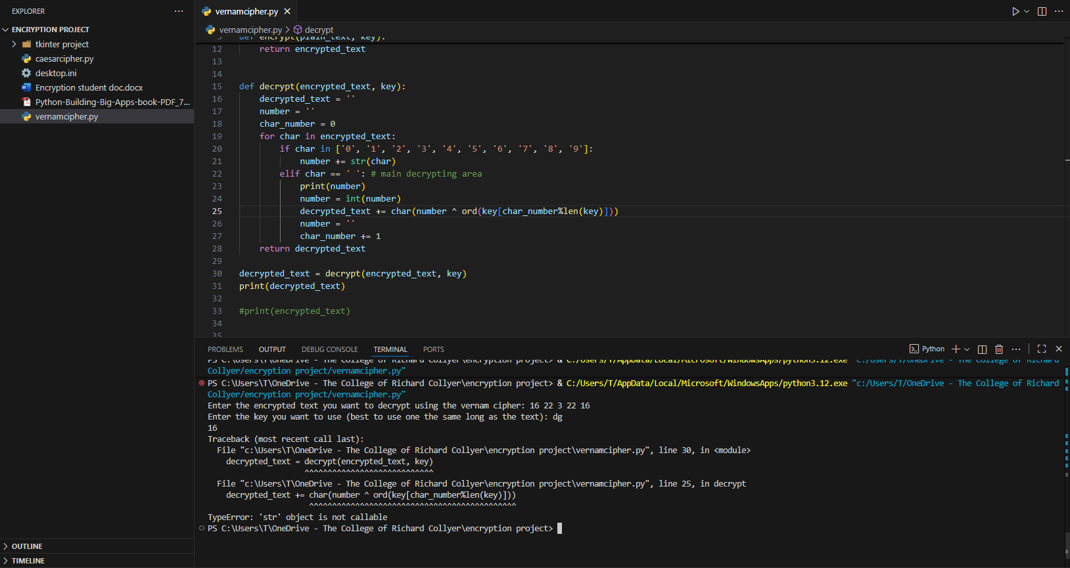
I misspelled the inbuilt function chr as char which is a variable in my program, and this function should convert integer values into ascii characters

-------------------------------------------------------------------------------------------------------------------------------
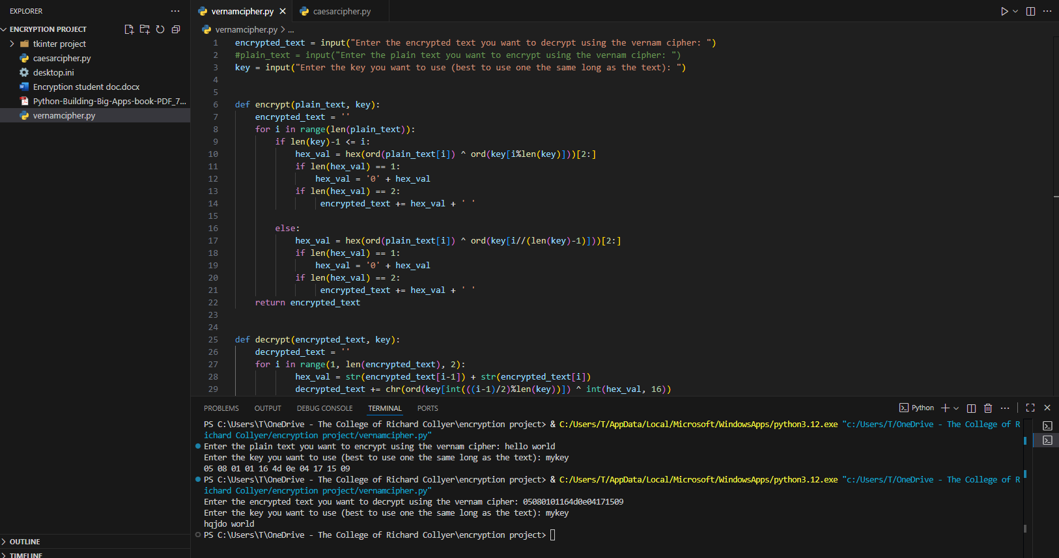
When i encrypt a piece of text and then decrypt it i get a piece of text that closely resembles the starting plain text but it is not exact.
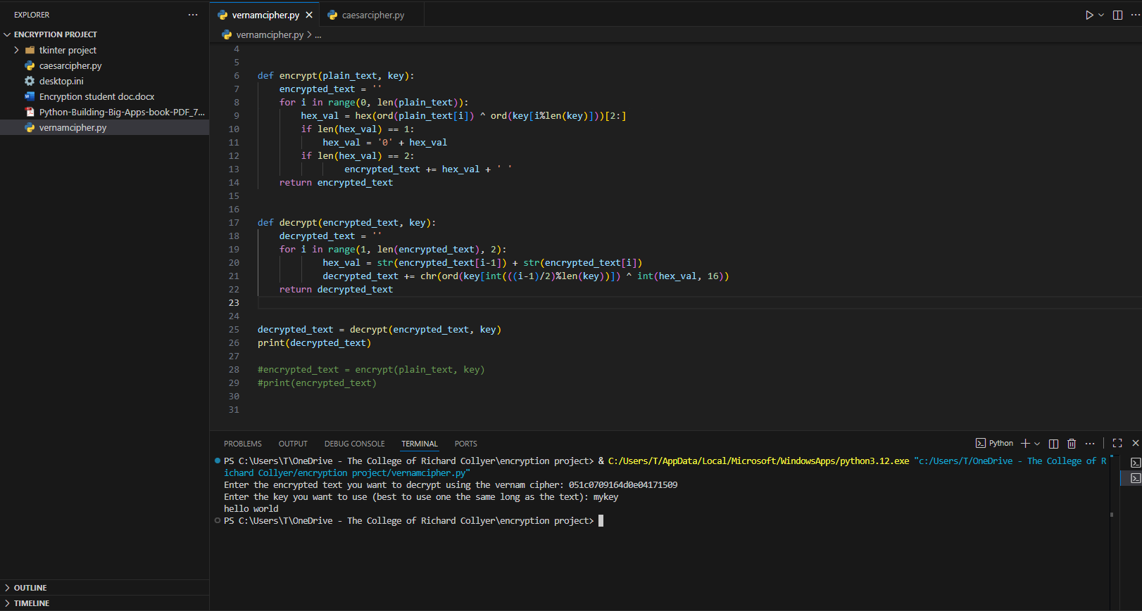

I fixed it and it was due to some faulty logical code in the decrypt function where I was accessing a previous character
------------------------------------------------------------------------------------------------------------------------------------

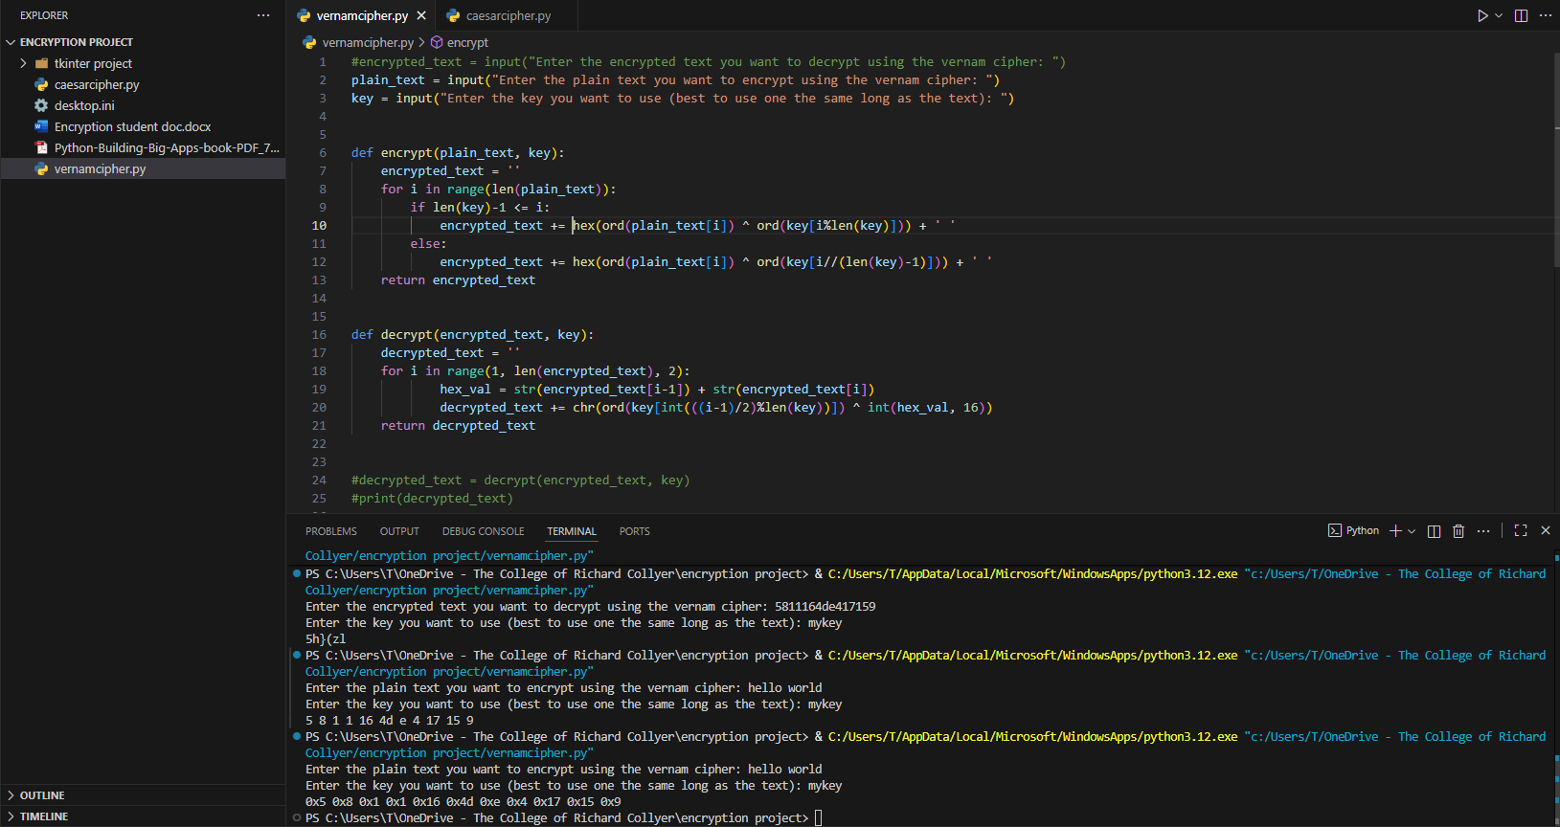
The hexadecimal output isn't formatted correctly resulting in some outputs being 1 digit long whereas some are 2 digits which will mean creating a decryptor will be impossible since it wont know here the end of one hex value and the beginning of the next
So i will check the length of the output – using the inbuilt len() function - and if its 1 then i will insert a leading 0 and if its 2 then it will append it to the encrypted text result

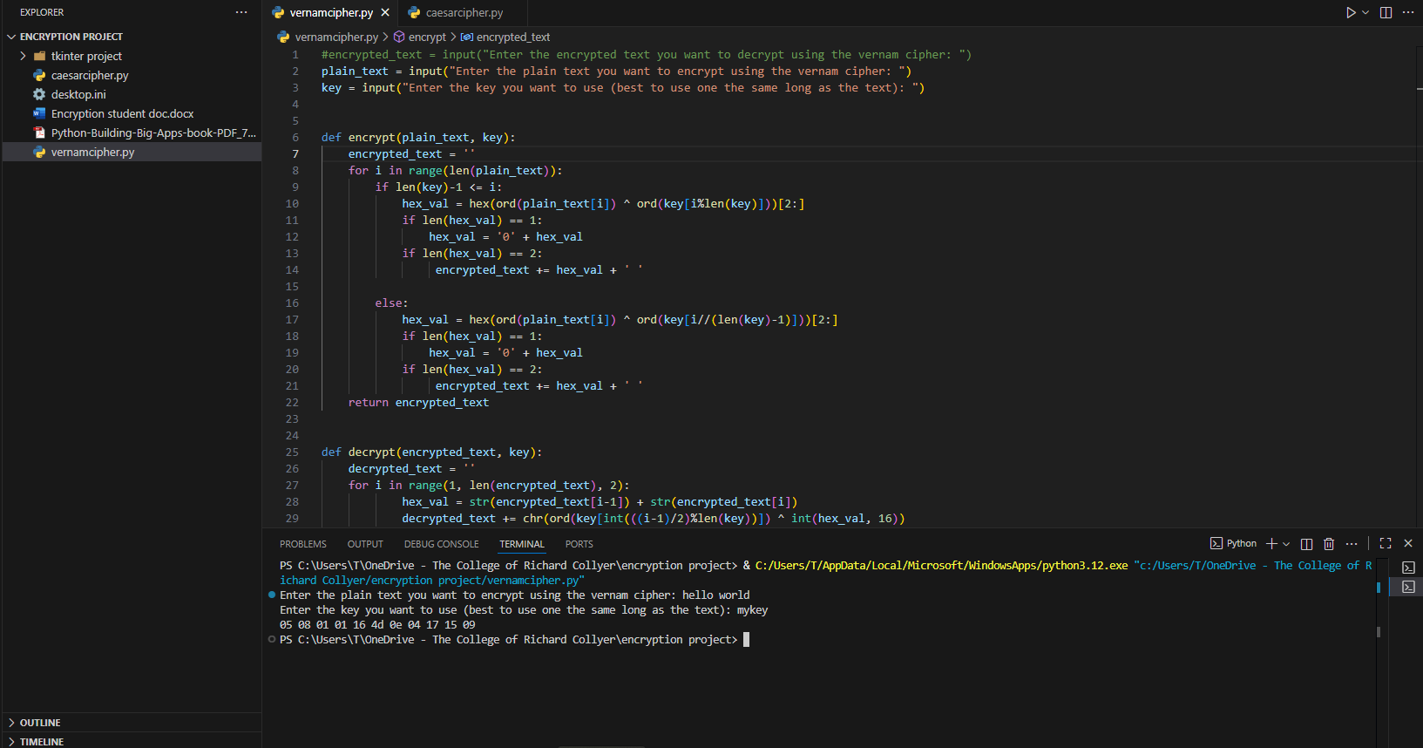
------------------------------------------------------------------------------------------------------------------------------------
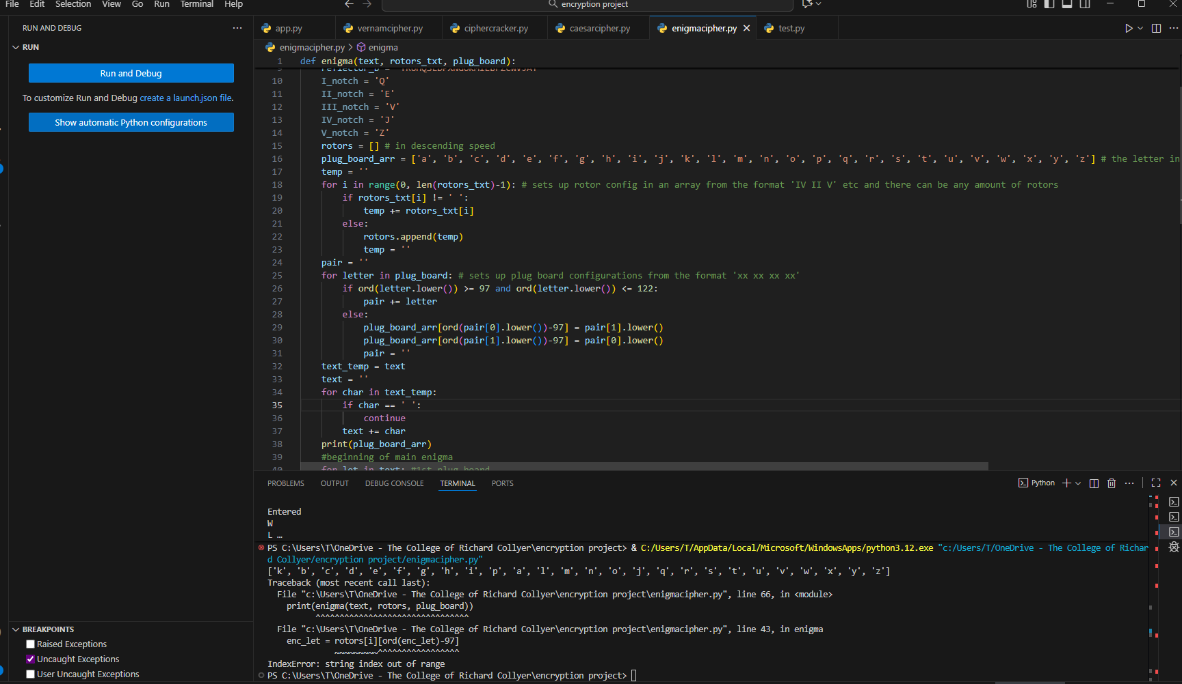
When setting up the plug board configuration the enigma program wouldnt swap the final two letters (in this case L and W) and so i will try to add the letter swapper once more outside of the for loop.

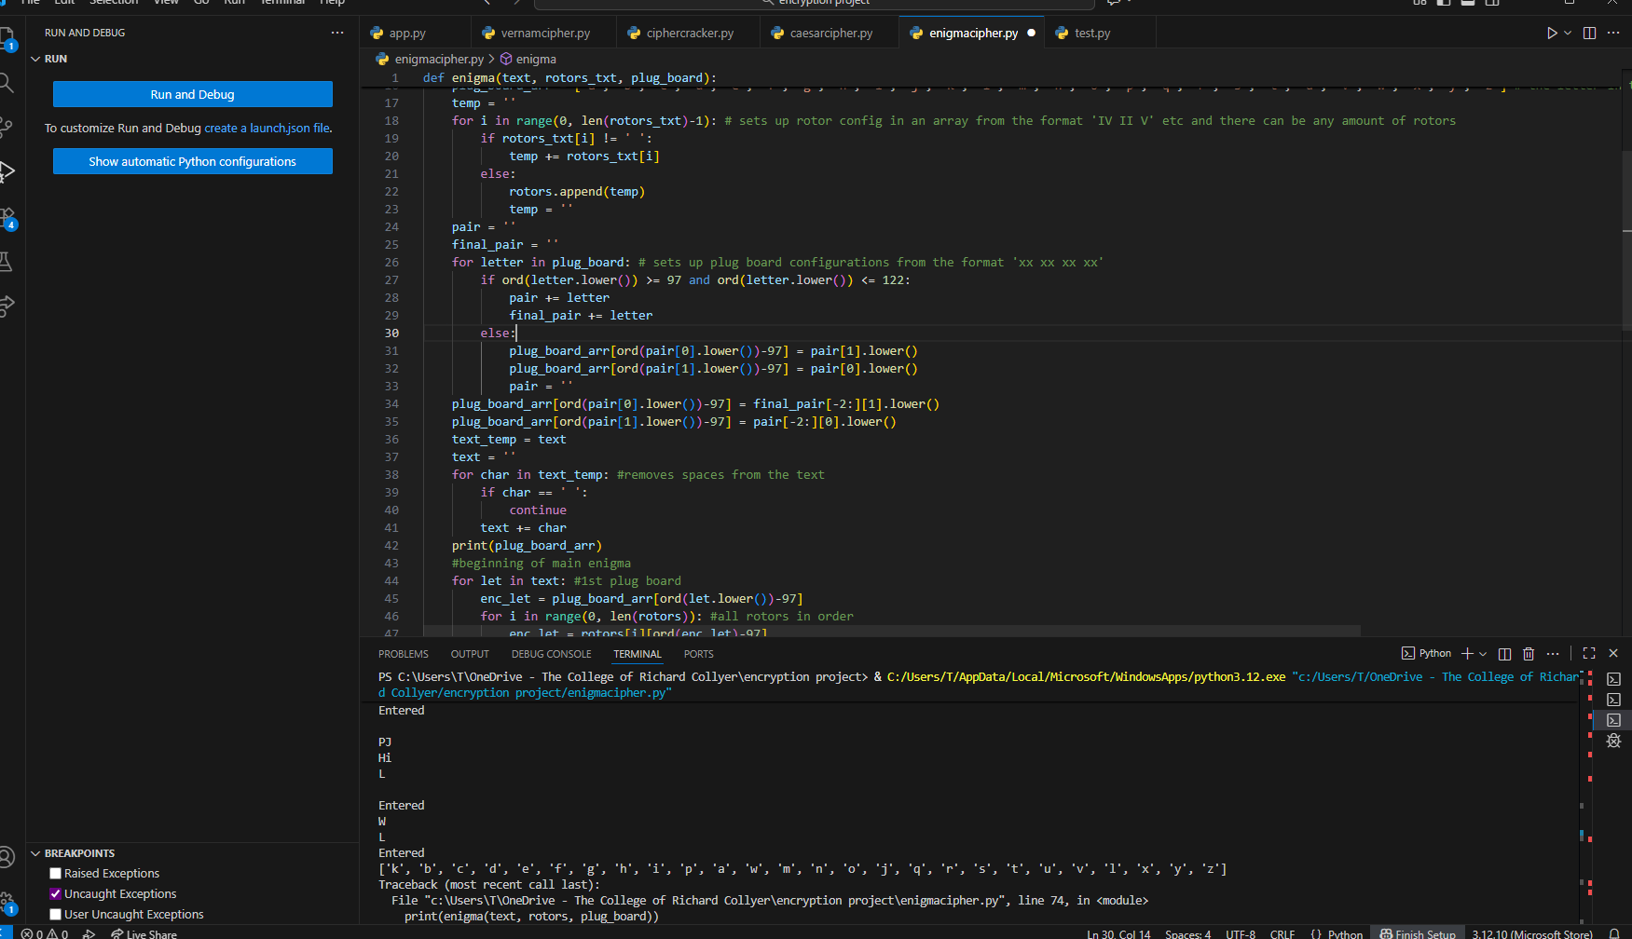
----------------------------------------------------------------------------------------------------------------------------

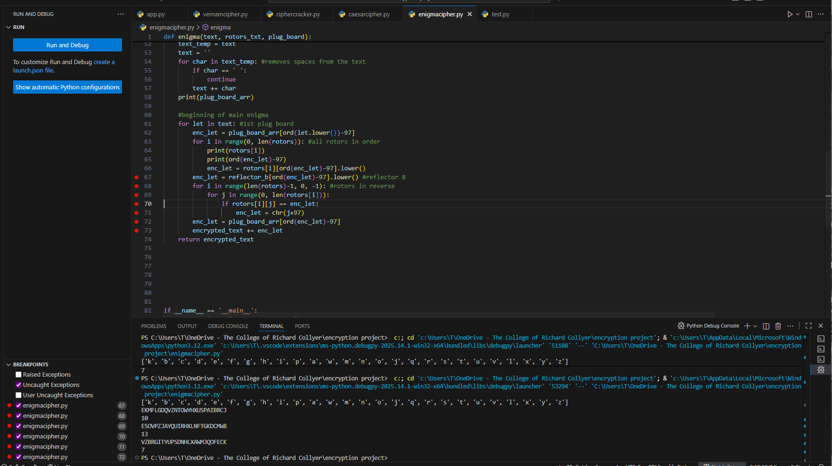
The reversing of the rotors isnt working properly so i will attempt to break down the logical steps using a debugger

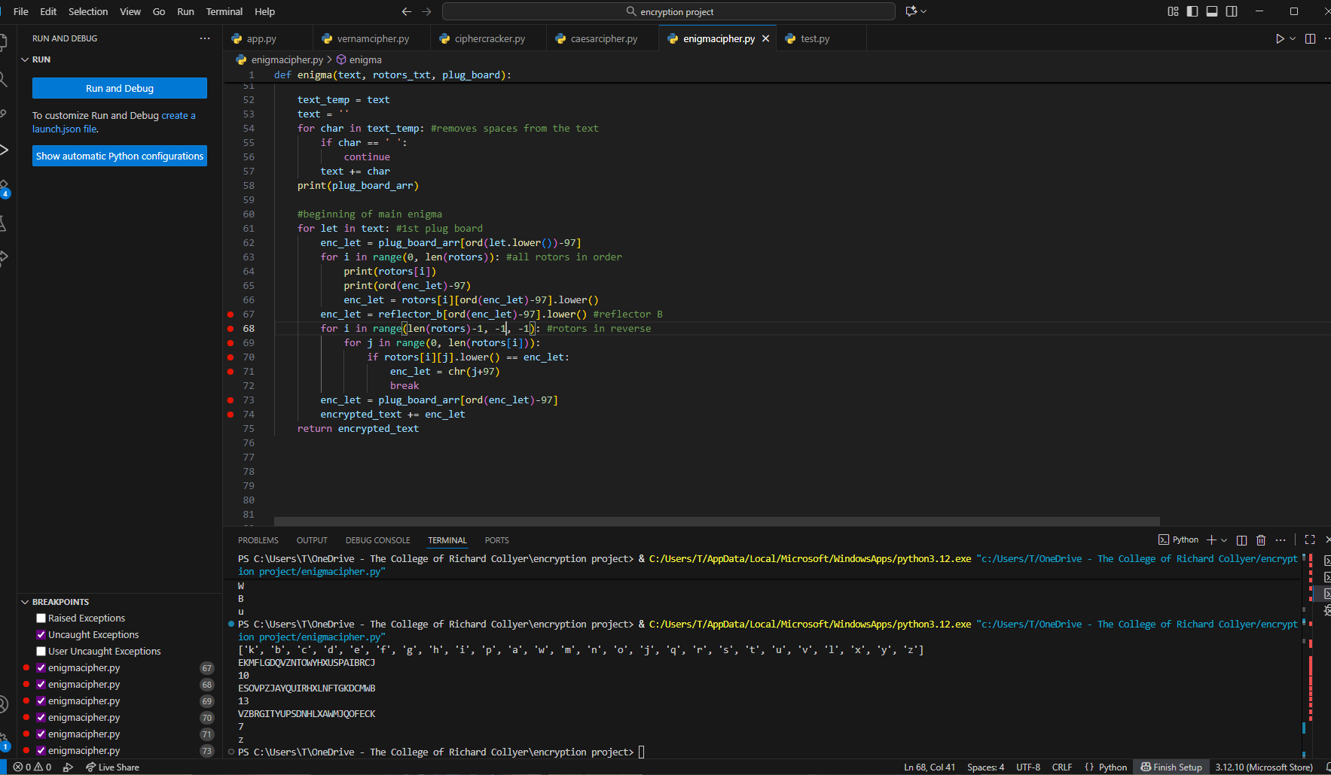------------------------------------------------------------------------------------------------------------------------------------
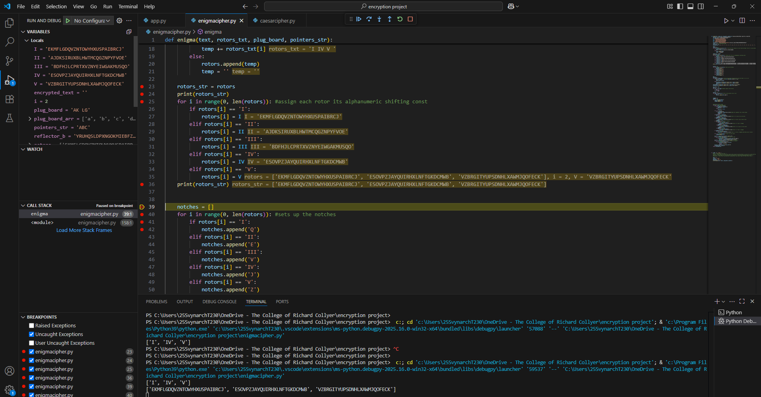Ive seen that rotors_str changes its contents exactly as rotors even though ive never directly changed it so i will have to try to find another way to copy the rotor list such as using the inbuilt .copy() method.

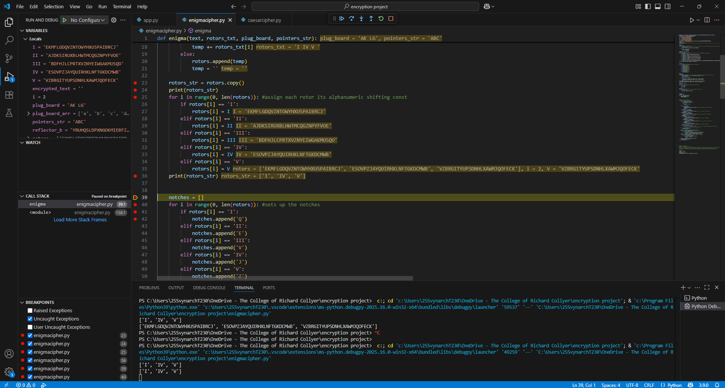I ended up using a shallow copy method which only preserves the outer layer but it will be good enough since the rotors list wont become a nested list in my program
--------------------------------------------------------------------------------------------------------------------------------
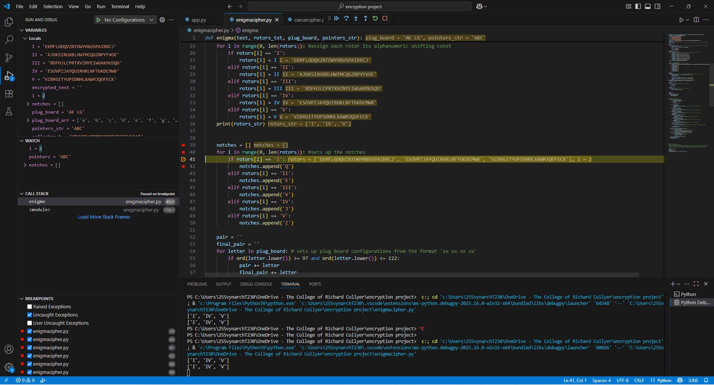
My notches list isnt being appended with any notches even though the program is passing by the lines where it should be getting appened

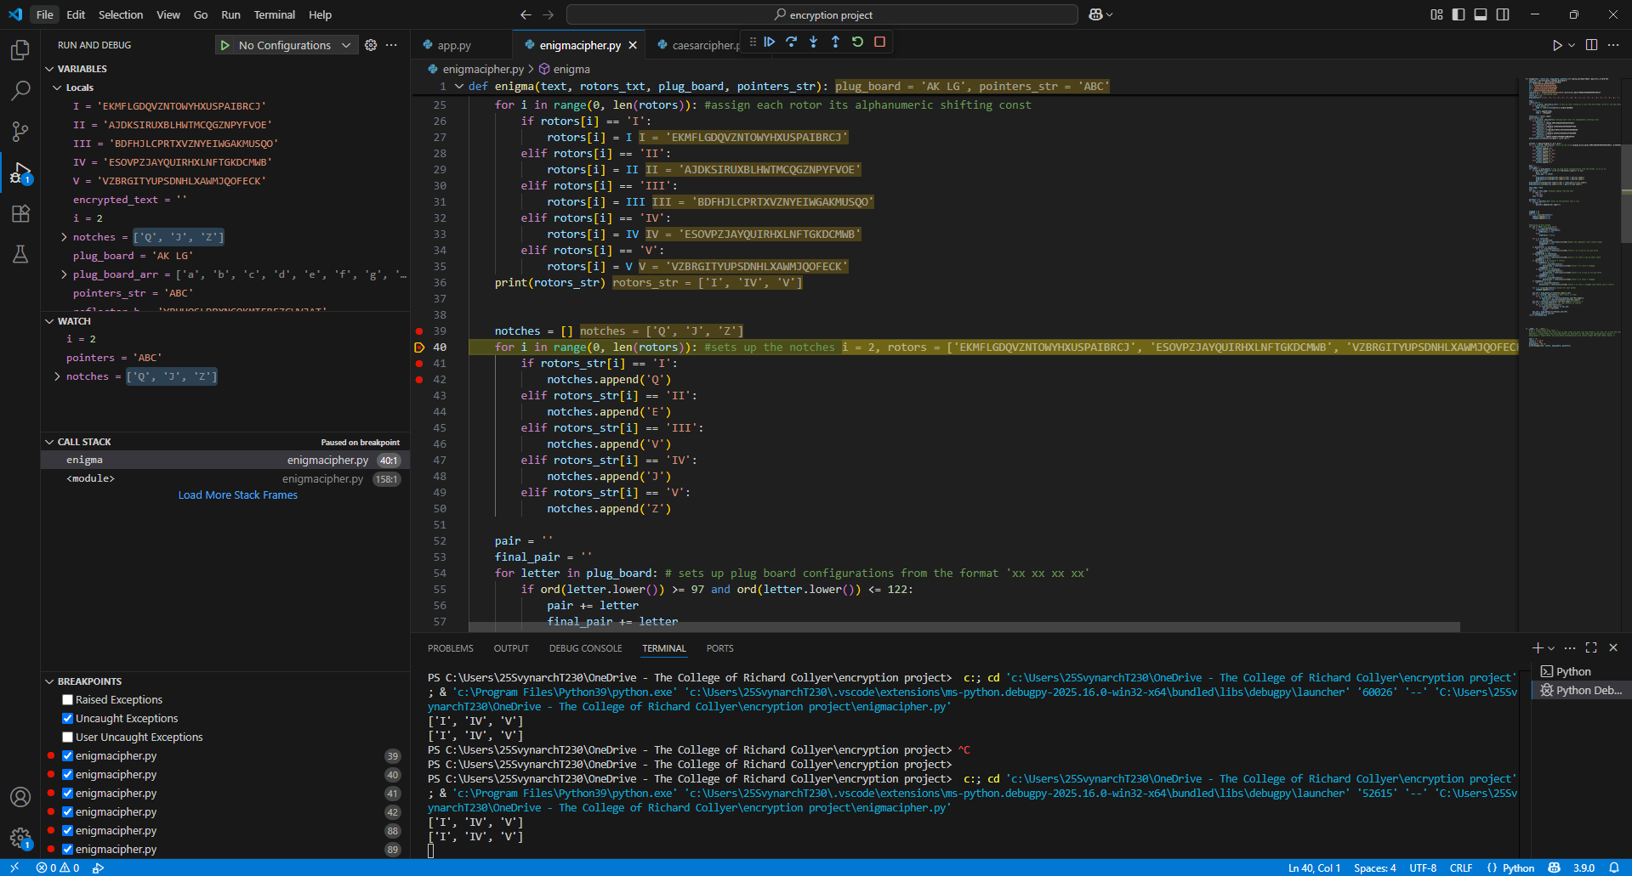Turns out i was accessing the wrong list – i shouldve been accessing rotors_str but i was accessing rotors instead.
-------------------------------------------------------------------------------------------------------------------------------------

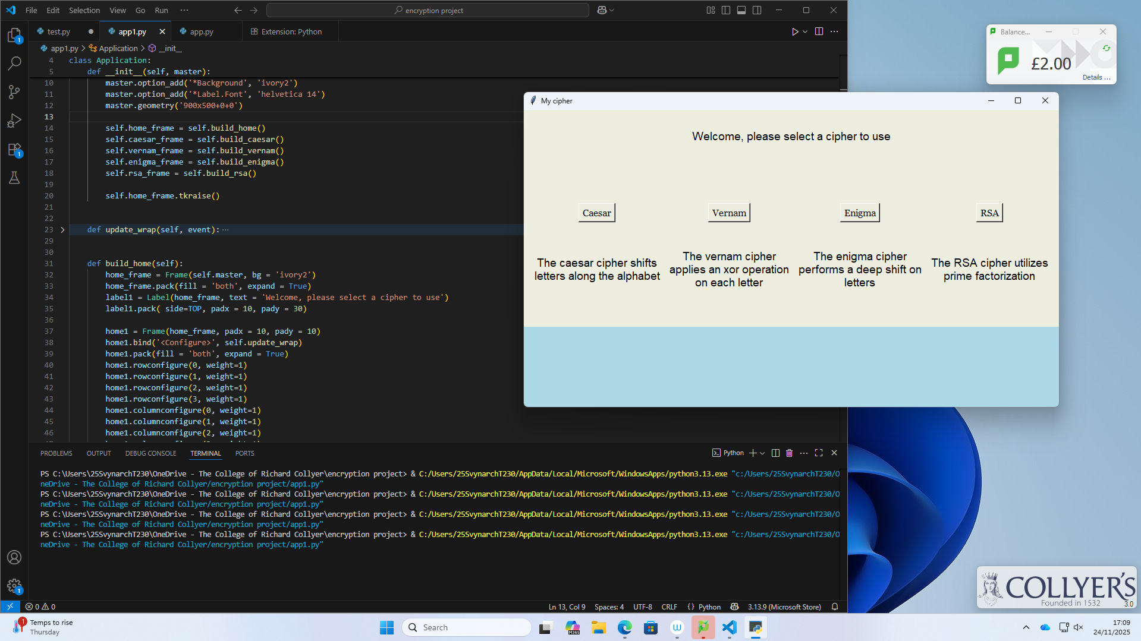
I am trying to make multiple pages to be stacked one behind the other (with the yellow one on top) but for some reason the blue page joined at the botom rather than behind the yellow page. I will try solving this by using the place method rather than the pack method

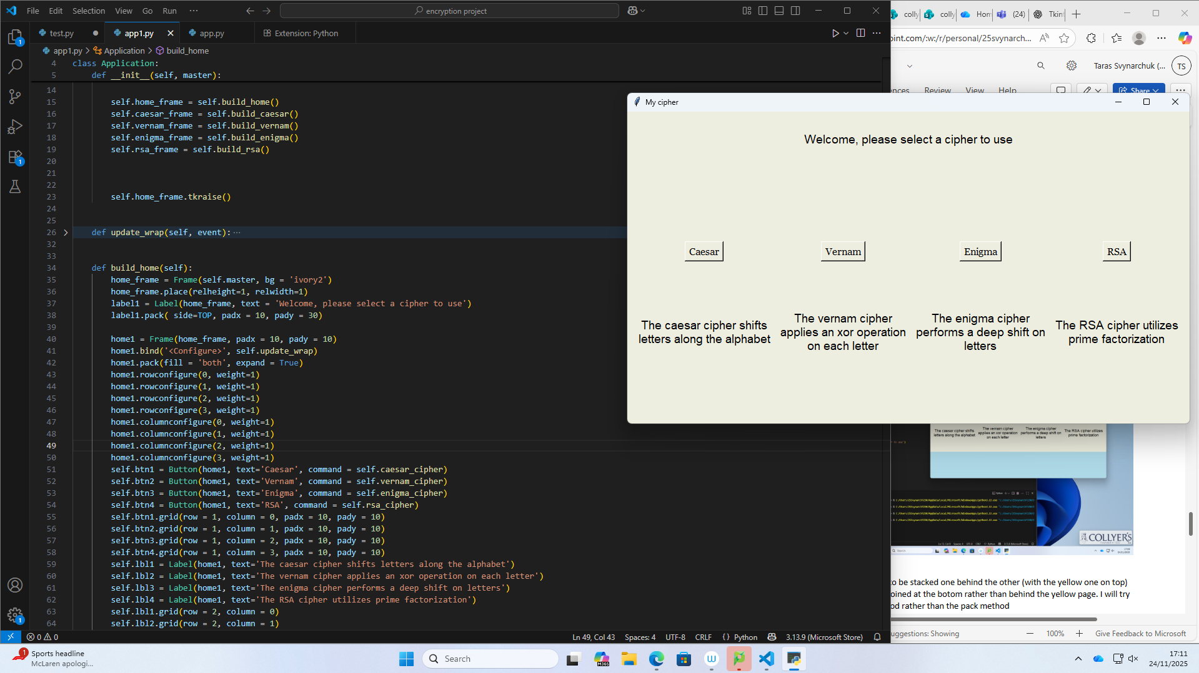
--------------------------------------------------------------------------------------------------------------------------------

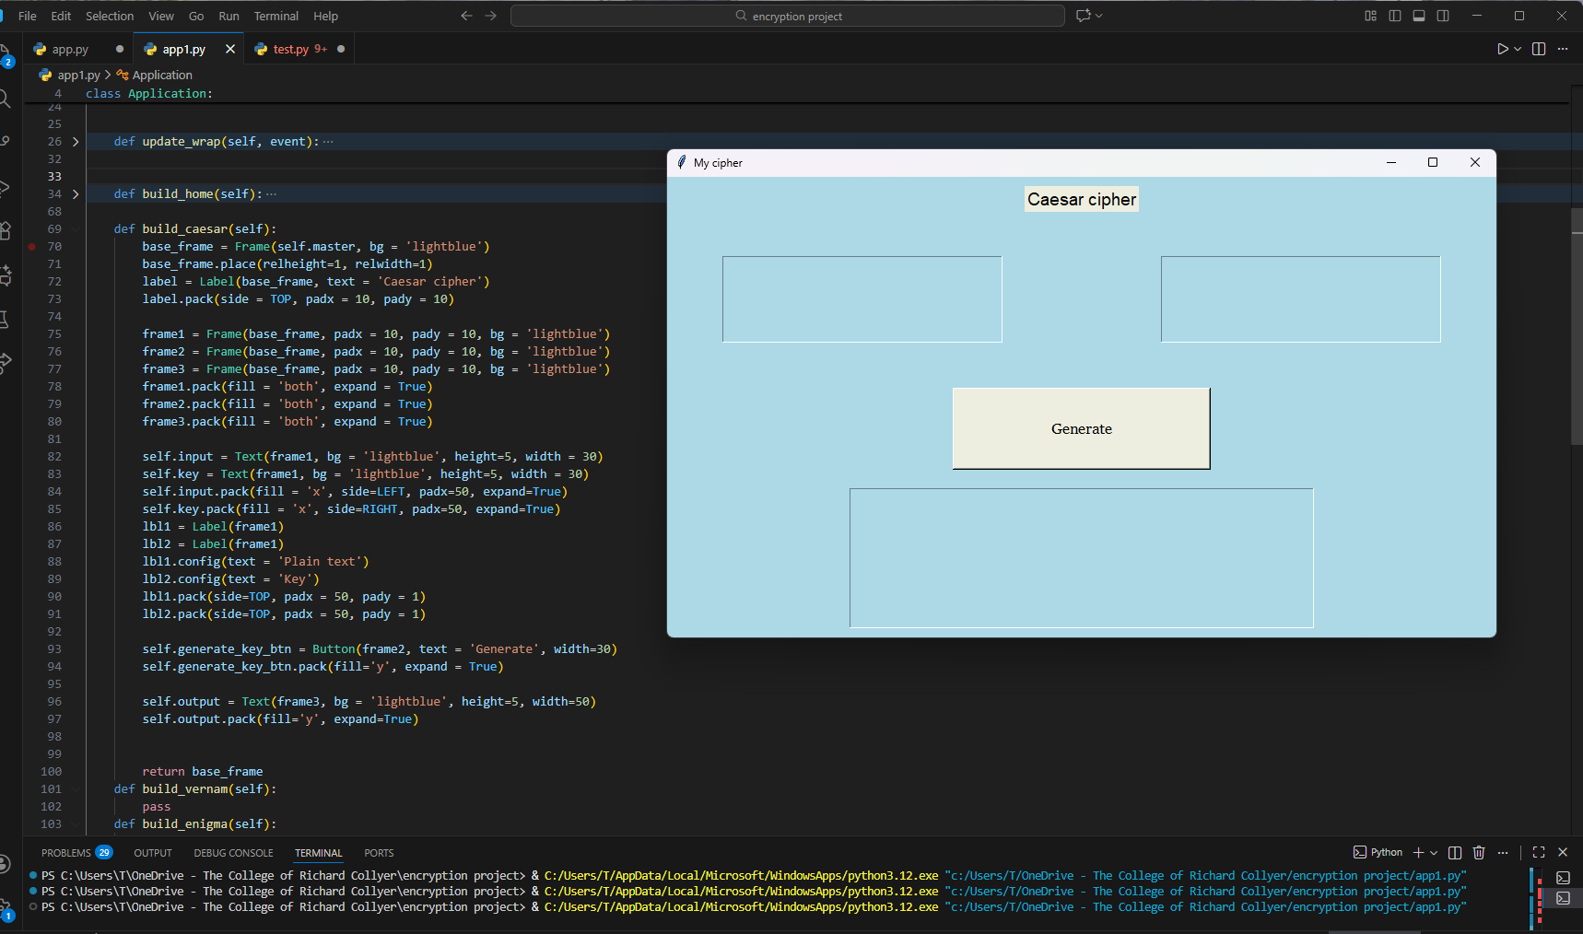
The text ’Plain text’ and ‘Key’ arent appearing above their text box widgets due to the way widgets are packed so i will try using the grid method and restructure my whole page

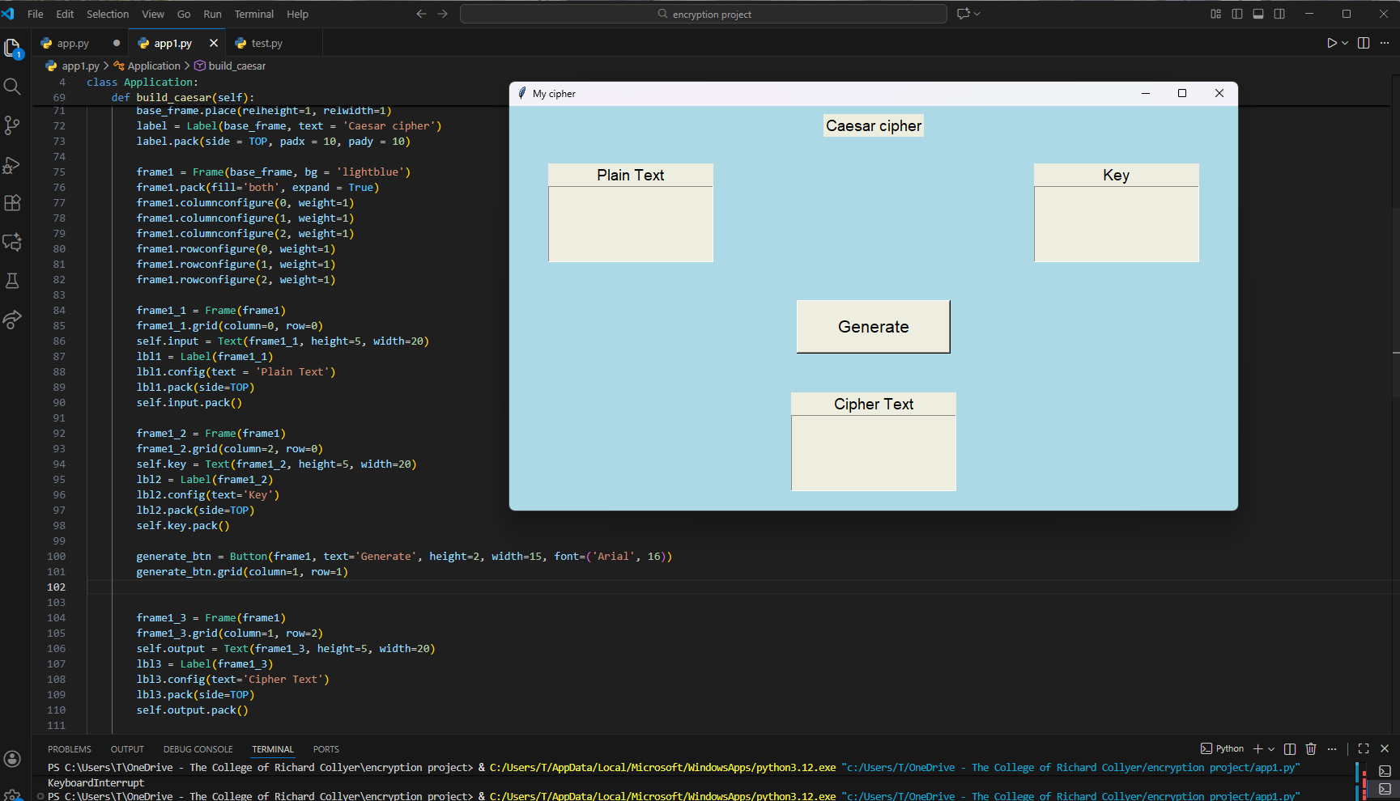I managed to get the labels correctly placed relative to the text widgets, now i just need to do some customization

------------------------------------------------------------------------------------------------------------------------------
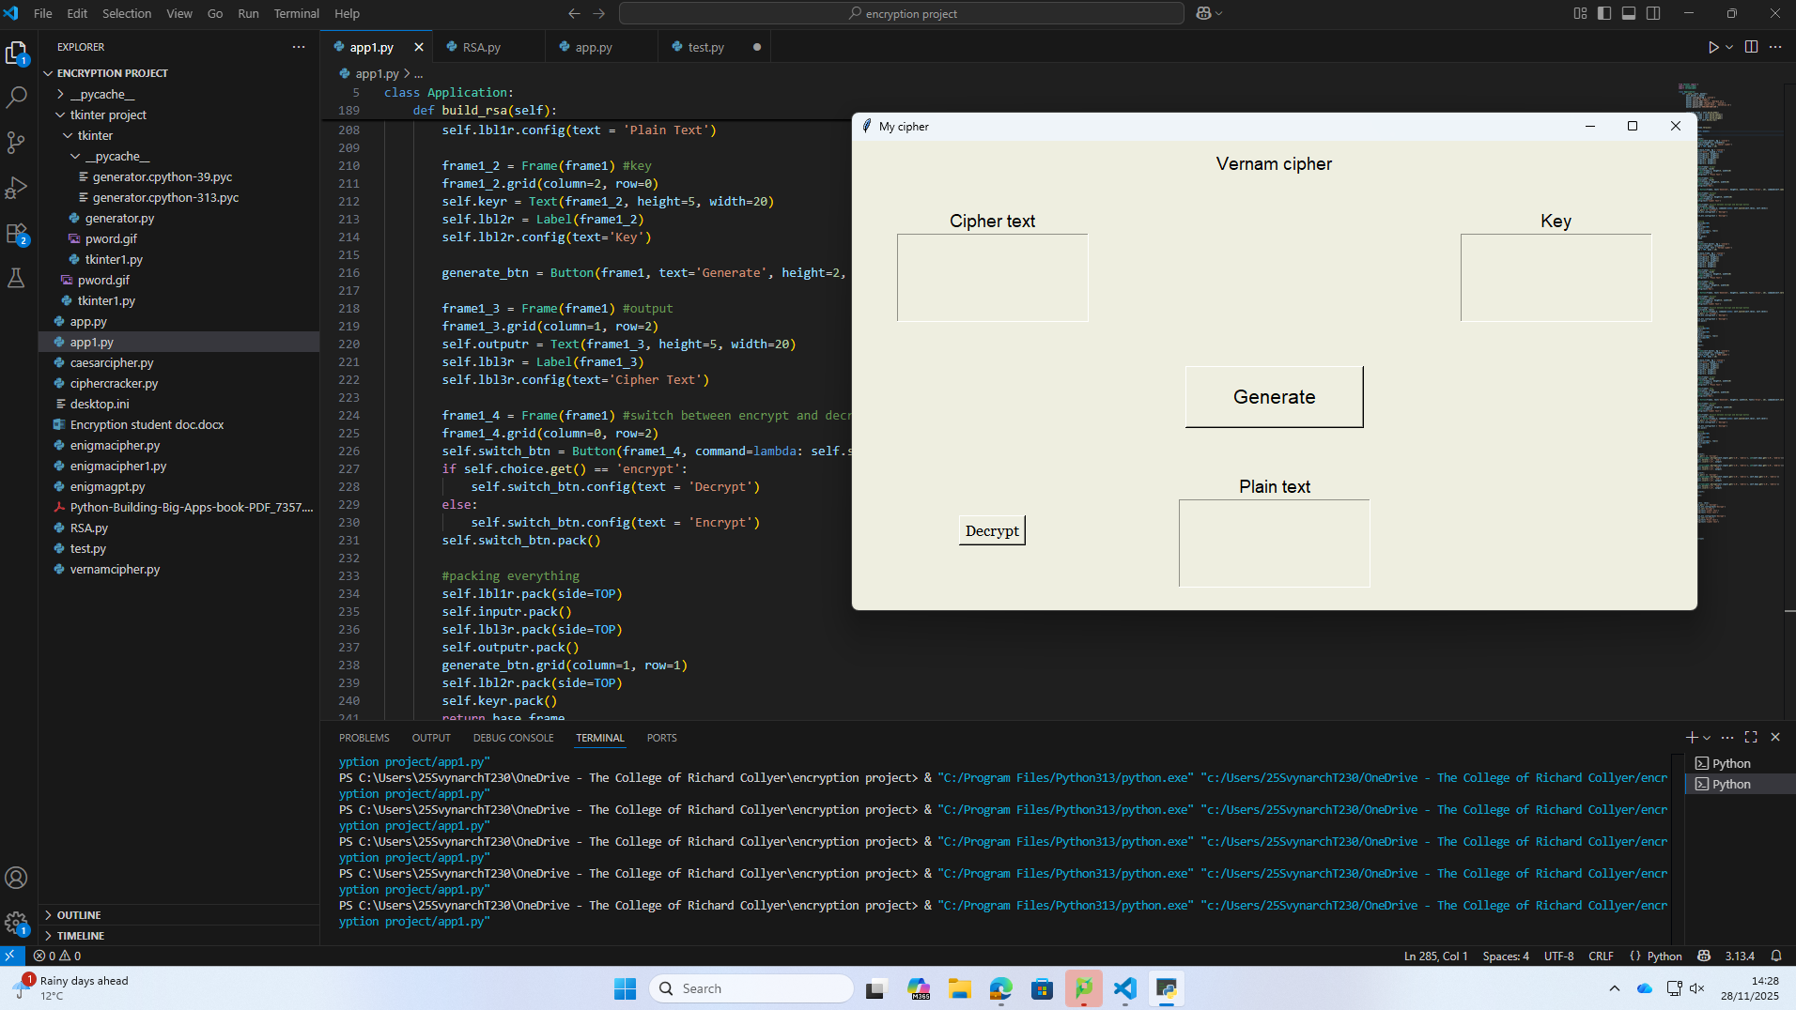
My program is becoming quite hard to read and use so i think i will create a class inorder to make the pages and keep it simple

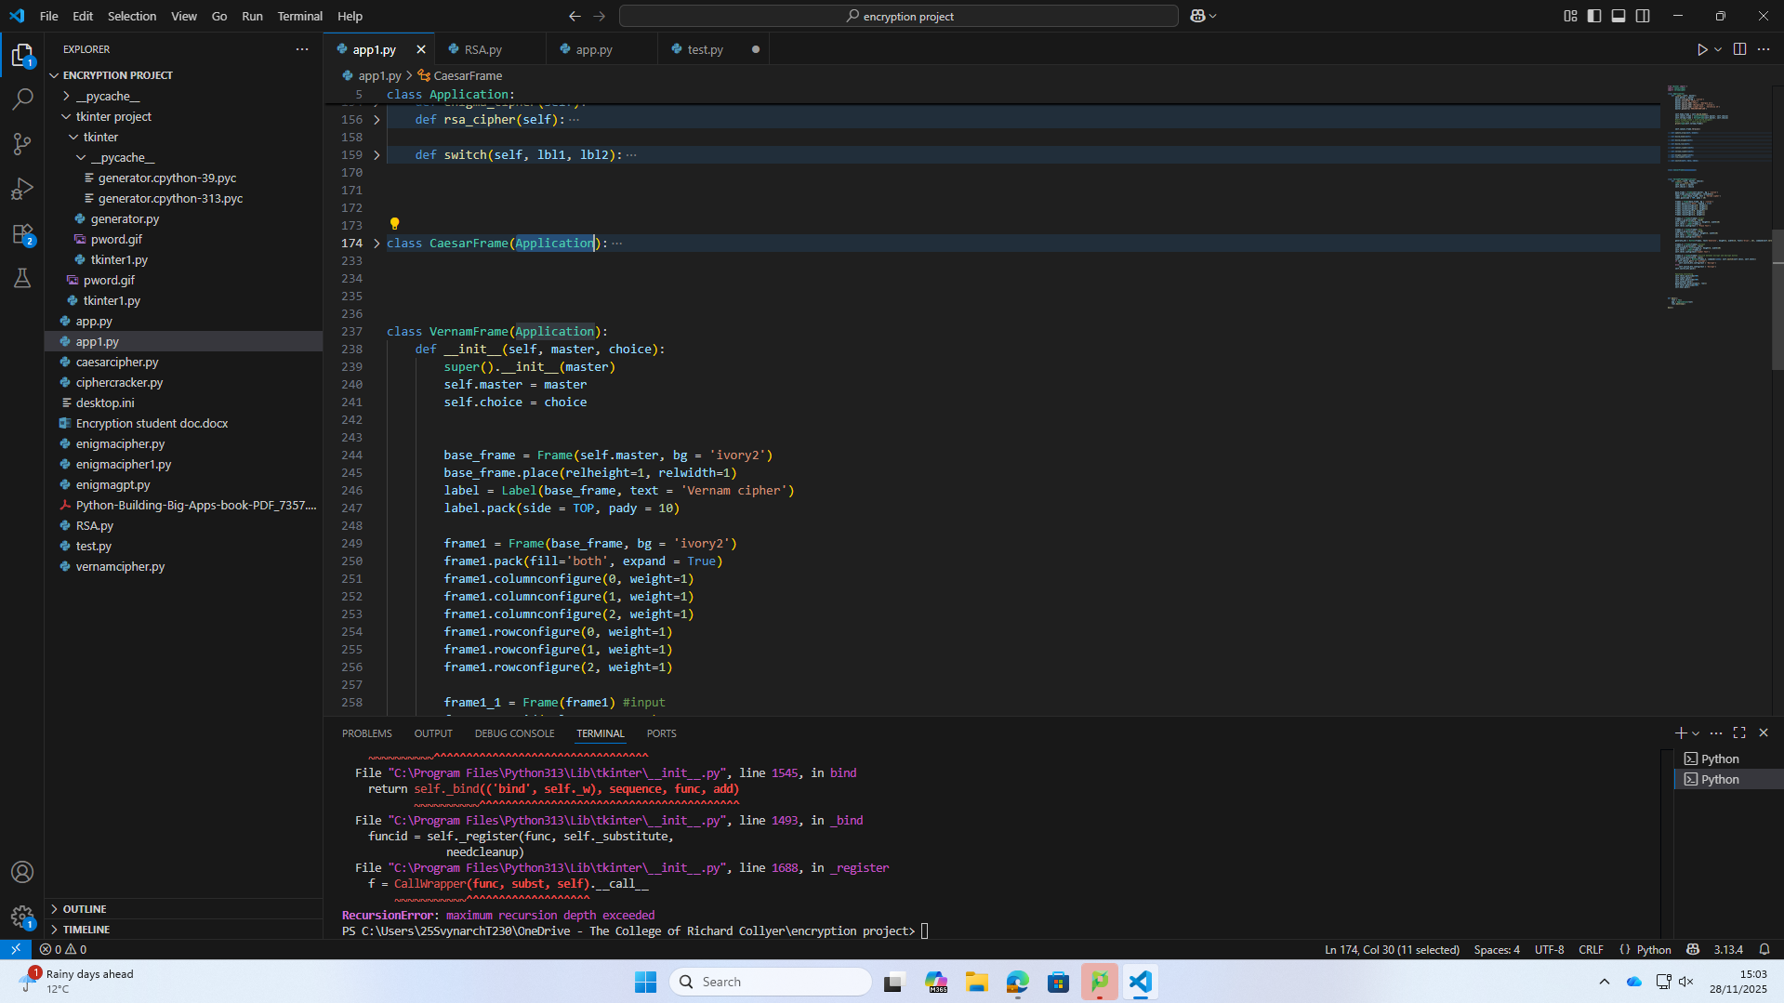
Whilst trying to implement classes for each frame i ran into a recursion error – i believe its because of some incorrect inheriting
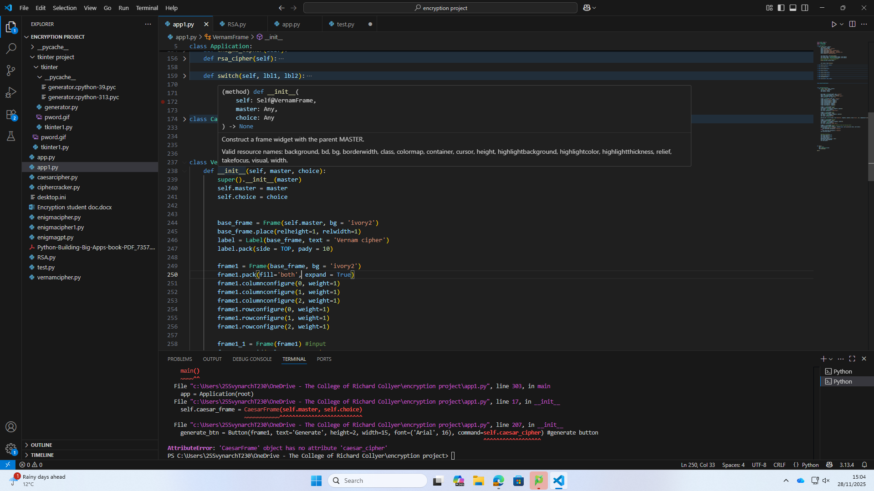
Theres no more recursion error and now i just have some undefined functions relative to the CaesarFrame class which should be simple to fix
------------------------------------------------------------------------------------------------------------------------------------
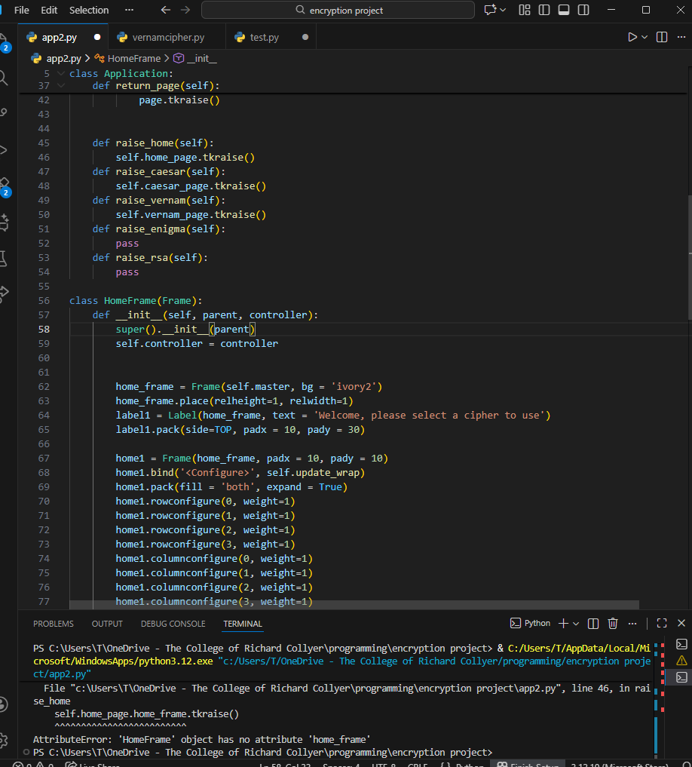
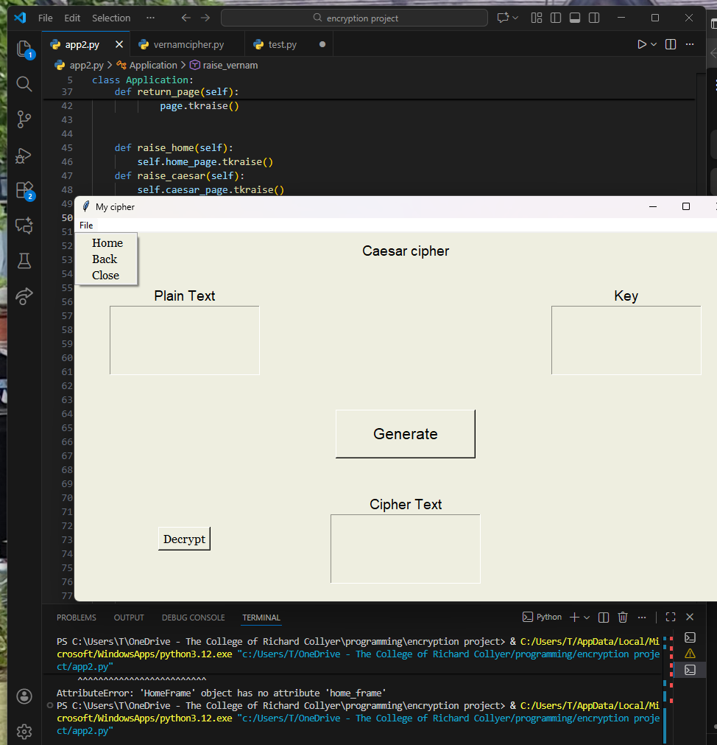C
When clicking on the home tab my program doesnt display the home page, i believe its because of some faulty frame assignment code in the HomeFrame class
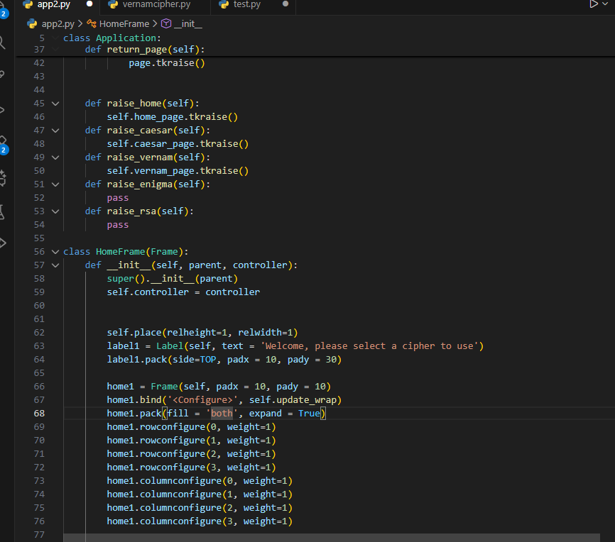I switched out the home_frame variable as that was storing all of the home page widgets and replaced it with self so it references the instance directly when raising it.
-------------------------------------------------------------------------------------------------------------------------------

When using the quick copy to clipboard button and pasting the output i was getting errors involving new line characters which means the button is copying the text incorrecty.
Turns out i needed to use the ‘end-1c’ parameter rather than ‘end’ for the 2nd index when using the get method and my rsa cipher also was appending an additional space character at the end of every encrypted message which lead to errors when using the split method for strings to separate each grouping of numbers.

Testing
Complete the following testing table, you will split the table and have lots of images.
Test | Sample data | Expected result | Actual result | Comment
Caesar cipher | Hello world  key=5 | mjqqt btwqi
Vernam cipher | Uncrackable  key= qwertyuiopa | kjgitaeipae
Enigma cipher | My name is taras  rotors =  I (1, A)  II (1, A)  III (1, A)  Plugboard = AT BS DE FM IR KN | dffmgvkrltsdt
Rsa cipher

Evaluation
Produce a detailed evaluation of the effectiveness your solution, you should consider the following.
- How does it compare to the sites you researched at the beginning
- Have you met all the aims and objectives? You should refer to these by number
- What features of Python have you used and how did this help? Or not?
- What you have done well and what you would like to change if you were to repeat the task.

